Tab 1

# Overview and Design Space

## Problem Statement

Despite the abundance of food ordering platforms such as Doordash, GrubHub, Uber eats, etc., many of these services still rely on generic, business-focused food recommendations that overlook the nuances of individual dietary habits and personal lifestyles. Many apps prioritize popular, advertiser-driven options rather than addressing the particular needs of users who observe specific eating patterns—such as designated vegetarian days, fasting periods, or other unique dietary routines. This lack of tailored insight often results in a repetitive cycle of uninspired choices, where consumers face overwhelming menus without clear guidance that resonates with their personal preferences.

Furthermore, current platforms seldom integrate dynamic, real-time information—such as cost fluctuations, localized restaurant details like closing times or portion sizes, and community-driven insights from social media and personal networks—that could enhance the decision-making process. The absence of these critical features leaves a significant gap in user experience, leading to decision fatigue and missed opportunities for discovering new, appealing dining options that are both health-conscious and uniquely suited to individual lifestyles.

## Report of alternatives/competitors and why they do not solve the problem

* Food ordering applications (e.g., Uber Eats, Doordash, GrubHub, Postmates)
  + Although food ordering applications provide access to a variety of restaurants, they focus on convenience and delivering foods rather than personalization and catering to the users needs.
  + Recommendations on these platforms are based on popularity rather than an individual's specific preferences and dietary restrictions.
  + Users have to manually filter and search to find options that best suit their needs, which can lead to frustration and inefficiency.
  + Food delivery apps are mostly useful for people ordering food, not for people who prefer going to restaurants in person.
* Google maps
  + Not always accurate, especially when it comes to opening hours.
  + Not dedicated to food discovery, mostly helps when they already know what kind of food they want.
  + Useful for determining proximity
  + Does not list common food allergies
* Yelp
  + Yelp provides restaurant reviews including ratings and photos, but it lacks tailored recommendations for users.
  + Yelp’s filtering options are limited and don’t always account for a user's dietary restrictions or specific food preferences.
  + Instead of simplifying a users decision making process there are many reviews and ratings which can confuse the user and lead to a choice overload.
* Tiktok
  + Not dedicated to food discovery, used like a general search engine.
  + Users appreciate the presence of dedicated food reviewers. Often features reviewers local to where users are.
  + Allows for “popularity-based” choices, a.k.a most liked, most viewed, etc.
  + There are restaurants and dishes that go viral but may not be suitable for every user. These trends drive user recommendations but can lead to bad experiences for users because it’s not specific to their needs.
  + It's difficult to filter options because the user must manually search and go through videos rather than receiving tailored recommendations.
  + It’s difficult to explore new and different options than what the algorithm knows about the user and the content it pushes.
* TripAdvisor
  + Enjoyed the ranking system for various restaurants, but did not like the system, only ranks food based on types of cuisines
  + Did not like the user interface, did not think it was visually appealing
  + Does not list common food allergies
  + Unknown metrics for computing rankings

## Proposed approach after analysis that builds on formative user research

We are proposing **Foo-d-Mah**, a food recommendation app that understands the specific needs and dietary options of the user and recommends food based on a variety of factors as outlined below:

**Social Media for food**

* App uses the user's current location to query nearest restaurants and search reddit posts, google maps and Yelp reviews to filter out specific key terms that are preferred by the user like Quantity of food, restaurant vibes, and quality of food. Citations to reviews from specific sources are also included to users for data authenticity.
* User Generated Content:
  + Users could connect with friends and other users in the app
  + Users could create posts to review food in the app, and ask other users opinions/votes.
  + Users get periodic recommendations on the new restaurants that their friend tried and the reviews they gave for the specific restaurant that the user might visit.
  + Users visiting restaurants with certain number of friends (based on location of users relative to the restaurant) get bonus rewards from restaurants (e.g $10 rewards, etc for loyalty)

**Community Surveys and Real-Time Feedback**

* Users receive feedback surveys through the app based on the restaurant they visited and are asked to provide:
  + Updated opening hours
  + Restaurant and food quality
  + Restaurant vibe and social outlook
  + Food allergy triggers

**Vendors profile**

* Food and street vendors could create account in the app as "vendors"
* Vendors register their phone location
* Users could get recommendations for nearby street food/mobile vendors and food deals
* Users could locate nearest street food and also review the food deals and reviews from other users.

**Directions based food recommendation**

* By integrating "transit" app API, we help to query for transit directions to recommended food outlets.
* If the food outlet is not reachable or too far to reach by public transit it would be removed from recommendation

**New food recommendations**

* Users could checkbox food that they tried at a restaurant
* App adds negative weight to food tried by users and recommends new food matching user food preferences to them.
* New restaurant opened near a restaurant based on social media and community standards query is recommended to users.
* If most restaurants are open it is notified to users including the latest food deals related to them.

# 

# 

# Team Contract

**Team Name** Team 6 (until we find a better one)

**Team Members:**

1) Rawda Ghalban 2) Zoe Berrier

3) Yusra Hersi 4) Mo Salem

5) Mahmoud Ahmed 6) Rishi Selvakumaran



1. Day, time, and place for regular **team meetings**:

* flexible per week, meet once a week for a check-in
* set meeting times/ dates ahead of time

1. Preferred method of **communication** (e.g., e-mail, cell phone, wired phone, Piazza, face-to- face, in a certain class) in order to inform each other of team meetings, announcement, updates, reminders, problems:

* Group chat, Face-to-face in class and in-person meetings

1. **Decision-making policy** (by consensus? by majority vote?):

* By consensus/ compromise
  + tie? Convince someone to join your side

1. Method for setting and following meeting **agendas** (Who will set each agenda? When? How will team members be notified/reminded? Who will be responsible for the team following the agenda during a team meeting? What will be done to keep the team on track during a meeting?):

* Rotate/ volunteer to make the meeting agendas
* Notify via group chat as well as Google Calendar invite

1. Method of **record keeping** (Who will be responsible for recording & disseminating minutes? How & when will the minutes be disseminated? Where will all agendas & minutes be kept?):

* the same person who made the agenda that week



## Work Quality

1. **Project standards** (What is a realistic level of quality for team presentations, collaborative writing, individual research, preparation of drafts, peer reviews, etc.?):

* Everyone works 100%
  + work together as a team to make sure everything is up to team standards
* In meetings, the team will discuss & evaluate work and give feedback to previous work.

1. **Strategies** to fulfill these standards:

* constant communication
* reminders in the group chat
* stay on top of things during meetings

## Team Make-up

1. Please list each team member’s skills as they can contribute to the team/project

* Rawda: UI Experience, communication, etc.
* Yusra: Communication
* Zoe: Strategic/ coding
* Rishi: UI Research
* Mo: Figma experience, Accessible design
* Mahmoud: Figma experience, Usability/User Testing, Presenting presentations, Communication, Getting stuff done even if last minute.

## Team Participation

1. Strategies to ensure cooperation and equal distribution of tasks:

* communication with the whole team
* make sure everyone’s voice is heard
* cooperate with each other
* be transparent about life responsibilities

1. Strategies for encouraging/including ideas from all team members (team maintenance):

* Some prepared to meetings (bring ideas, or thoughts or food)
* Reviews & feedback to each member’s work.
* Take into consideration any dissent

1. Strategies for keeping on task (task maintenance):

* Consistent check-ups for progress
* Agreeing on deadlines to be met individually and as a team.

1. Preferences for leadership (informal, formal, individual, shared):

* Shared

## Personal Accountability

1. Expected individual attendance, punctuality, and participation at all team meetings:

- Attend all meetings and if it's not possible to attend, try to catch up on the discussion materials by contacting one of the team members who turned up for the meeting.

1. Expected level of responsibility for fulfilling team assignments, timelines, and deadlines:

- Complete assignments and any work at agreed upon deadlines and or due dates

- Any unfinished work by deadlines, try to catch up quickly with give notice asap

1. Expected level of communication with other team members:

- communicate when unable to meet deadlines, meet outside of class, and miss class

- communicate within 24 hours if questions or comments arise in group chat

1. Expected level of commitment to team decisions and tasks.

- everyone contribute equally to given tasks

- everyone contributes equally to discussions and team decisions



1. Describe, as a group, you would handle **infractions** of any of the obligations of this team contract:

* Communicate with each other to see if we can get to a solution. If not, involve the teaching team

1. Describe what your team will do **if the infractions continue**:

* Consult with the teaching team, decide further steps

***************************************************************************

* 1. *I participated in formulating the standards, roles, and procedures as stated in this contract.*
  2. *I understand that I am obligated to abide by these terms and conditions.*
  3. *I understand that if I do not abide by these terms and conditions, I will suffer the consequences as stated in this contract.*
     1. Rawda Ghalban DATE 02/05/2025
     2. Yusra Hersi DATE 02/05/2025
     3. Mahmoud Barbary DATE 02/05/2025
     4. Mo Salem DATE 02/05/2025
     5. Zoe Berrier DATE 02/05/2025
     6. Rishi Selvakumaran DATE 02/05/2025

# Consent Form

You are invited to be in a class project investigation of UI Design - CSCI 5115. We ask that you read this form and ask any questions you may have before agreeing to take part. This class project is being conducted by: Rawda Ghalban, Zoe Berrier, Yusra Hersi, Rishi Selvakumaran., Mahmoud Ahmed, and Mohammed Salem, in the Computer Science Department at the University of Minnesota.

**Procedures:**

1. Introduction – I’ll introduce myself and explain the purpose of this research.
2. Consent Form – I’ll review the form with you, answer any questions, and ensure you agree to participate.
3. Interview/Questionnaire – I’ll ask you some questions based on our research plan, but I may also ask follow-up questions to gain deeper insights.
4. Note-Taking – I’ll take notes throughout to accurately capture your responses.
5. Conclusion – I’ll wrap up the interview and thank you for your time.

**Risks and Benefits of Being in the Study:**

Some risks are privacy, data misinterpretation, and emotional discomfort. There is a risk of information being shared with project group members and supervisors. Some questions may cause discomfort to participants. There is a risk of information being misinterpreted during the interview. The benefit of participating in this study is helping to understand common problems and finding effective solutions. Participation in this study ensures decisions made are based on the user’s needs.

**Data Sharing:**

The information you provide through this project may be recorded or transcribed into text. Data that you provide as part of this class project will be shared with the following people: the other students on the project team, and the course staff. No names or personal data will be shared.

**Confidentiality:**

We will not collect any information that will make it possible to trace your participation back to you and will not share your participation with anybody outside of the student project team and the course staff. We will keep your participation private to the extent allowable by law.

**Voluntary Nature of Project Participation:**

Participation in this project is voluntary. Your decision whether or not to participate will not affect your current or future relations with the University of Minnesota. If you decide to participate, you are free not to answer any question or withdraw at any time without affecting those relationships.

**Contacts and Questions:**

The students conducting this project are: Rawda Ghalban, Zoe Berrier, Yusra Hersi, Rishi Selvakumaran, Mahmoud Ahmed, and Mohammed Salem. The instructor supervising this class project is Loreen Terveen. You may ask any questions you have now. If you have questions later, **you are encouraged** to contact him at Keller 5-211 or email at [terveen@umn.edu](mailto:terveen@umn.edu)

**Statement of Consent:**

I have read the attached information regarding the class project Smart Food Recommendation App. I have asked questions and have received answers. I consent to participate in this class project.

Signature:____________________________________________ Date: __________________

Signature of Interviewer:_________________________________ Date: __________________

# User Study Protocol

## Synopsis

The plan is to interview anyone who eats out, including people with dietary restrictions and food allergies. Finding any common problems someone might have with finding places to eat. Interview people to learn about frustrations with current food ordering/review apps.

## User Population

People who eat out or would like to, target those who have dietary restrictions and other niche preferences in order to have a more personalized experience catered to them.

Here we acknowledge that since cities and metropolitan areas often contain a high density of restaurants, we will be focusing mostly on city residents.

## Point of Research

* Does there exist a strong need for a different platform when it comes to finding restaurants/places to eat in our user population?
* Does our user population encounter significant difficulty or inconvenience when using platforms to find restaurants and places to eat?
* How often do users want to try out new kinds of food/restaurants?
* Do users prefer to stick to what they know when it comes to applications even if there are things they don’t like?
* How do users’ dietary restrictions and preferences affect their experience on the restaurant-finding platforms they use?

## Steps/Logistics (our plan to achieve our goal)

1. Determine the demographics to conduct research on.
2. Build a consent form, interview plan, and questionnaire.
3. From the demographics, determine specific people to interview, each member selects at least one.
4. Introduce ourselves. Explain what we’re trying to accomplish.
5. Review the consent form with users and answer any questions.
6. Ensure each participant agrees to the research and completes the consent form.
7. If the user consents to proceed, be sure to provide a copy of the form for the user to keep.
8. Go through the interview/questionnaire as constructed beforehand.
9. Be flexible and follow what we think helps our research best, interview questions that are not on our plan, or extra “Other” sections in the questionnaire.
10. In interviews, continuously take notes. Conclude and thank the interviewee afterward.
11. After the interview, data collected from questionnaires and interviews will be analyzed to help create a solution to common problems users face.

## Ethical Considerations/Consent

* Participants will be informed that their responses are anonymous and completely optional.
* Participants can withdraw from the study at any time, and we will respect that.
* No personally identifiable information or private information of the user will be collected or stored.
* Data will only be used for academic purposes within the scope of the course.

## Interview Questions

1. How do you usually prefer eating out? What are some common behaviors when you do so?
   1. (Going to a restaurant - order online - call - pickup … )
2. How do you usually discover new restaurants and cuisines?
3. Have you ever had accessibility issues when utilizing food service apps?
4. What are the difficulties you face when finding new places to eat and using different food ordering platforms?
5. Recall a time when you wanted to go out to eat but were unable to. What place did you try to go to and were there any applications/websites you used?
6. What factors affect your decision to try new places (is it location, distance, preferences, etc…)?
7. What influences your choices when deciding whether to revisit familiar places or try something new when it comes to eating out?

## Survey

* How old are you?
* What is your gender?
* What are your favorite food types?
  + Options? (Fast Food - Japanese - Mexican - Chinese - Middle Eastern - Italian - Other)
* What are your dietary restrictions (if any)?
  + Give options (Allergies - Halal - Kosher - Vegetarian …)
  + Do you have a food schedule? (Vegetarian for specific days; Fasting on certain months)
* How often would you say you eat out?
  + Give options (1-2 times a week, more, less…)
* What platforms do you use to order food (select all that apply or textbox)?
  + Give options (Doordash, Postmates, instaCart, uberEats, restaurant website, other)
* What features from the selected options above do you like the most?

## Next Steps

We will analyze the findings from our user research and based on that, we can design the User Interface that mostly aligns with our target audience.

# Group Analysis

## User Study Data

[Individual Interviews](https://drive.google.com/drive/folders/19GgEeS1T-NJR43JmhFhEm8wqWPvXf3f9?usp=sharing) including transcripts, open coding, notes and signed consent forms. This is a link to a google drive folder containing all our interview data.

## Qualitative Analysis

### Open Coding & Affinity Mapping -> [Miro Board](https://miro.com/app/board/uXjVIX9ZuiQ=/?share_link_id=489215239769)

### Themes & Implications of Design

* Theme: People prefer eating in restaurants more than ordering online.
  + Implication: Location of places must be taken into account, as well as pictures and other elements that describe and illustrate the restaurant or place being shown.
* Theme: People prefer having reviews on restaurants and usually utilize them, but they might not show the full picture.
  + Implication: Include reviews of users to these places and their food, and make the process of reviewing more specialized to the context of trying new foods.
* Theme: People like trying new types of food, as well as new restaurants.
  + Implication: Store what the user has already tried or what places they’ve been to, and when recommending, push more “novel” options first to encourage that behavior.
* Theme: People have many sources to look for new food/restaurants in different places, and not all of them turn out to be helpful.
  + Implication: Have our solution be the centralized source for finding new places, having the helpful information while discarding the unhelpful ones.

## Quantitative Analysis

While conducting user research, the interviewees completed a survey in addition to the interview itself. Each figure is the users’ response to those surveys. Below is a description and analysis of each figure.

Figure 1

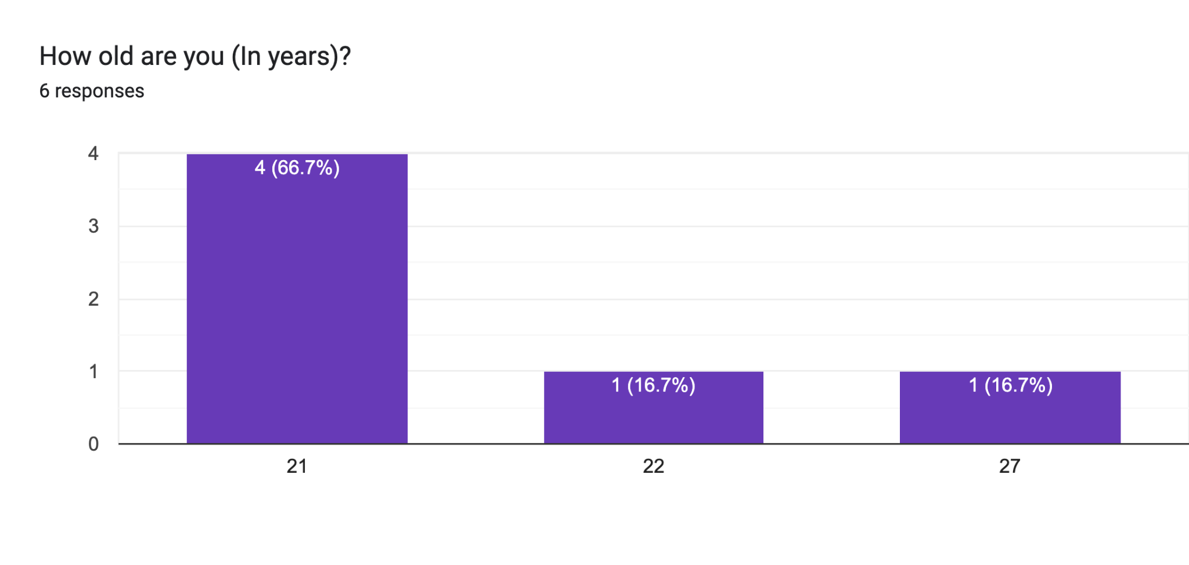

Figure 2

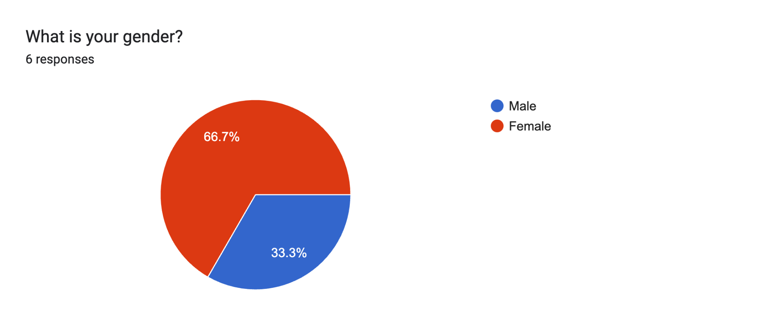

Figure 3

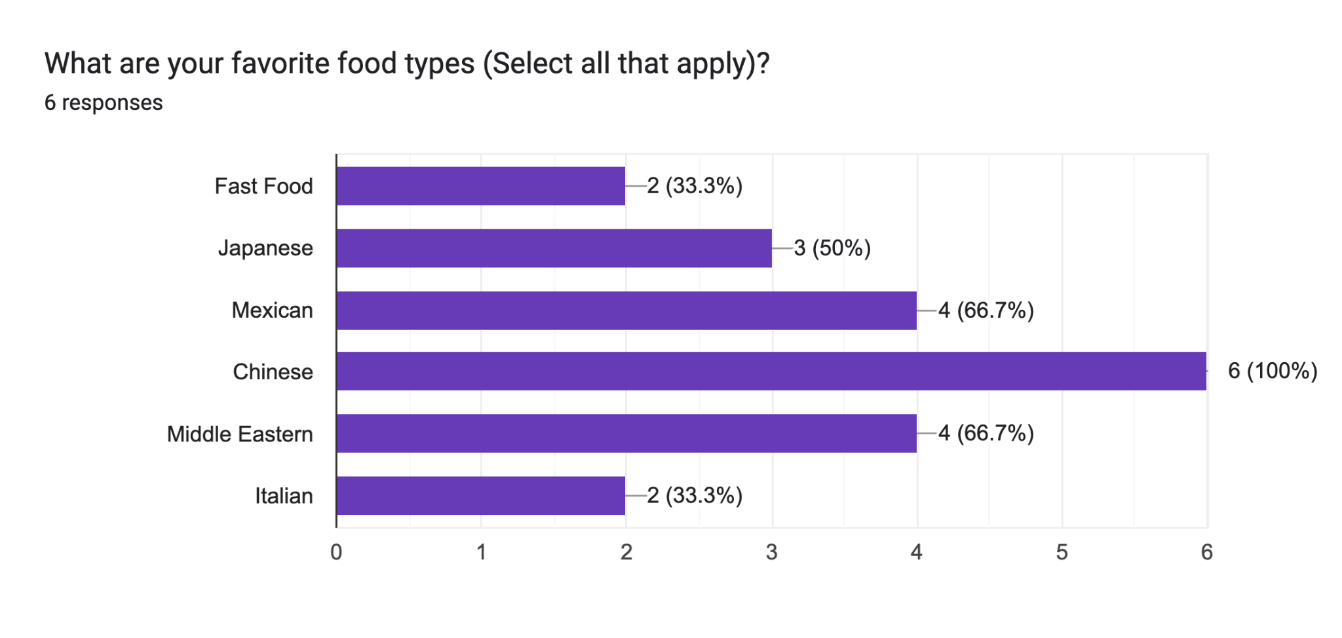

Pretty diverse distribution, fast food is lower than expected.

Figure 4

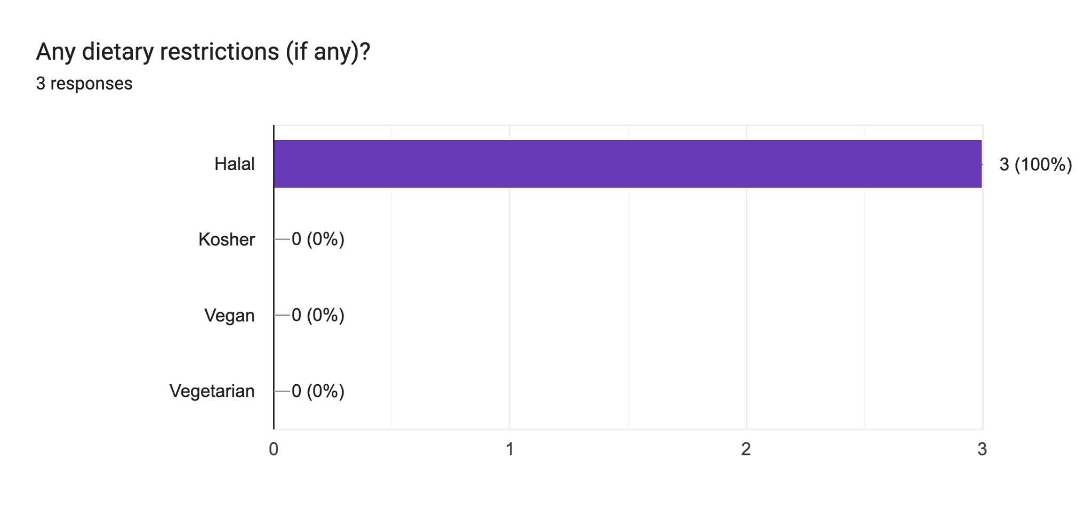

Figure 5

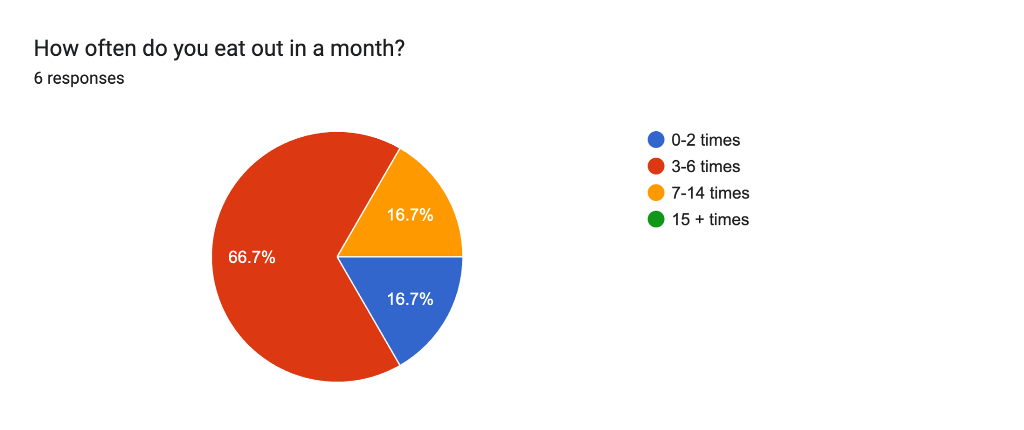

Figure 6

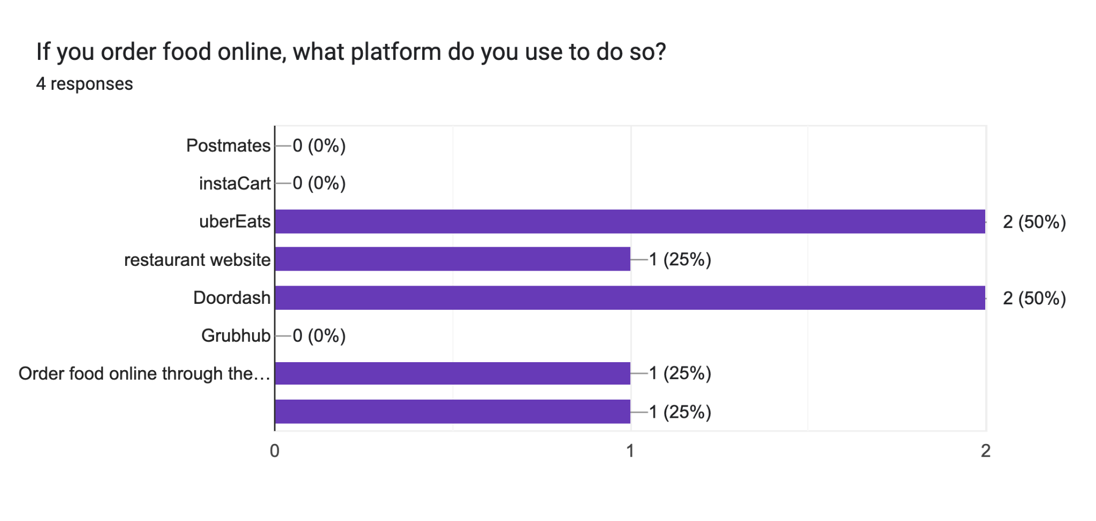

Figure 7

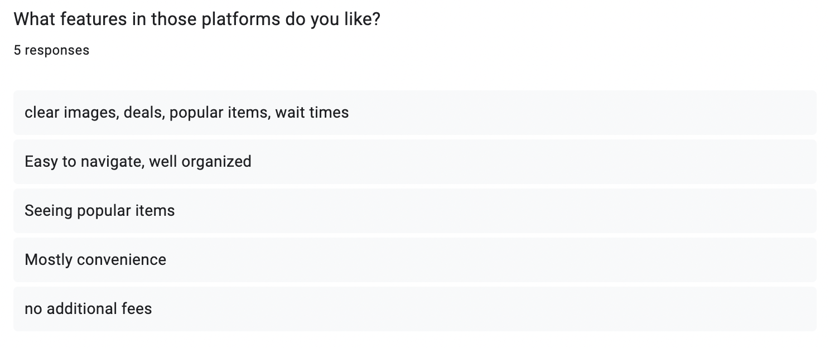

This question and its answers will help us infer what services users prefer in other, similar interfaces and alternatives.

## Interpretation of Figures

* Figure 1: Age distribution
  + The majority of respondents are 21 years old (66.7%), with another respondent at 22 years old (16.7%) and the other at 27 years old (16.7%). This suggests that most of the interviewees are within the same age group.
  + It is probably biased by the fact that we interviewed people that were colleagues/acquaintances in one way or another (co-worker for example) and thus they are more likely to be around our age.
  + The age range can impact user preferences as younger users are more likely to use social media as a tool to find food suggestions and prefer mobile friendly applications.
  + Our key takeaway from this was that our application should prioritize a user-friendly, modern interface that draws on social media platforms and reviews to make it easy to engage with.
* Figure 2: Gender distribution
  + The majority of respondents are female (66.7%) and the rest of respondents are male (33.3%). This distribution suggests that food and restaurant preferences could be influenced by gender based behaviors.
  + The key takeaway is to consider differences in dining priorities and preferences between gender groups and make personalized recommendations based on that.
* Figure 3: Favorite food types
  + This figure illustrates users' food preferences and demonstrates that users have diverse food preferences. Chinese cuisine is the most popular (100%), mexican and middle eastern foods are also preferred by a majority (66.7%), but fast food/italian had lower preference levels (33.3%). This data suggests that users lean toward more flavorful, diverse cuisines, and may appreciate a variety of ethnic restaurants.
  + Our key takeaway is that this application should highlight many international cuisines and give restaurant filtering options based on what type of cuisine they are looking for (i.e mexican, chinese, middle eastern, east african, indian, etc…)
* Figure 4: Dietary Restrictions
  + Among those that responded to this question, 100% of them noted they follow a Halal diet indicating that dietary restrictions and preferences play a big role in their food choices and where they eat.
  + The key takeaway is that the application should prioritize dietary restrictions/ allergy filtering options making sure that a user can easily filter restaurants based on their dietary needs (i.e halal, kosher, vegan, and vegetarian). Making these selections easily accessible can improve user trust.
* Figure 5: Frequency of eating out
  + Most respondents said that they eat out 3-6 times per month (66.7%) which showcases that dining out could be considered an occasional activity rather than a more frequent one. Only 16.7% of respondents said they eat out 7-14 times a week, and the rest stated they eat out 0-2 times a week (16.7%). This reinforces that users could be selective on when they eat out, and is likely not a daily habit.
  + Adding to this, people we interviewed don’t eat out too often, reinforcing that they do it more as a “special occurrence” than a recurring or frequent event.
  + The key takeaway from this data is to show more recommendations for special occasions, trending spots, and even group discounts. We should be focusing on quality over quantity, and making sure users get a great experience even if they only eat out once in a while.
* Figure 6: Online Ordering Preferences
  + Most respondents either chose DoorDash or UberEats (50% each), and other respondents preferred using restaurant websites (25%). Other food delivery services like GrubHub, PostMates, InstaCart weren’t used at all.This suggests that ordering food online is not as common as we first thought amongst people.

Putting this together with the other observed interview data and notes, it shows that dine in experiences are preferred over online ordering.

* + Our key takeaway was instead of prioritizing and advertising food delivery, we will focus on in person dining, location based recommendations, and more social settings.
* Figure 7: Features Users Like on Online Platforms
  + Respondents listed key platform features they value in other online food based platforms and many said they value easy navigation and visibility, being able to see popular menu items, and having it be convenient. This shows that users prefer simplicity, transparency, and convenience when it comes to food ordering applications.
  + Our key takeaway is that our application should incorporate all of these preferences including high quality menu previews and images, a user friendly and easily visible interface, popular and trending food locations drawing on social media, and real time restaurant wait times and deals.

# Ideation

This is a quick and rough prototype to what the “app” interface might look like, it showcases our “Mascot” idea which makes the app more friendly in a way that conveys the feeling of a friend recommending you a place.

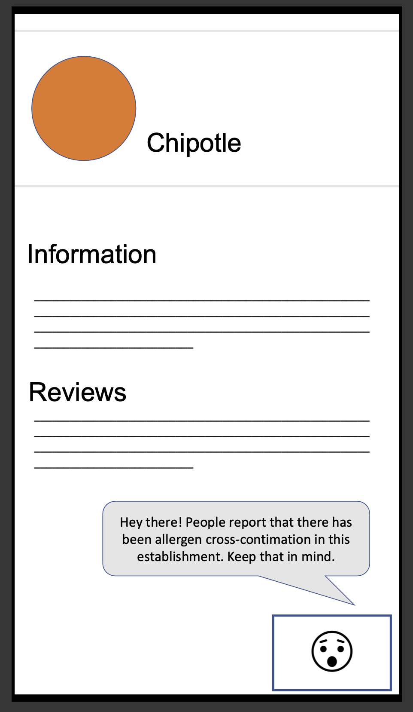

# Poster

[Canva Link](https://www.canva.com/design/DAGgndGQuwg/f45sh2JSDOszdL4BZUJ7qA/edit?utm_content=DAGgndGQuwg&utm_campaign=designshare&utm_medium=link2&utm_source=sharebutton)

Screenshot:  
